Zachary McNulty

AMATH 422

Problem Set 3

**Problem 1: Coupled Oscillators**

For this first problem, we analyze the behavior of a pair of coupled repressilators. The defining equations for these two equations are identical except for a new interaction term gamma * (…). When gamma is zero, we except the two systems to behave as independent oscillators. First, we define all our constants which were observed to produce oscillations in our single repressilator system. Then, we define the relevant differential equation. As there were 6 pairs of near identical equations, for simplicity we defined inner functions mn and pn for each equation. Then we just had to set which species were interacting.

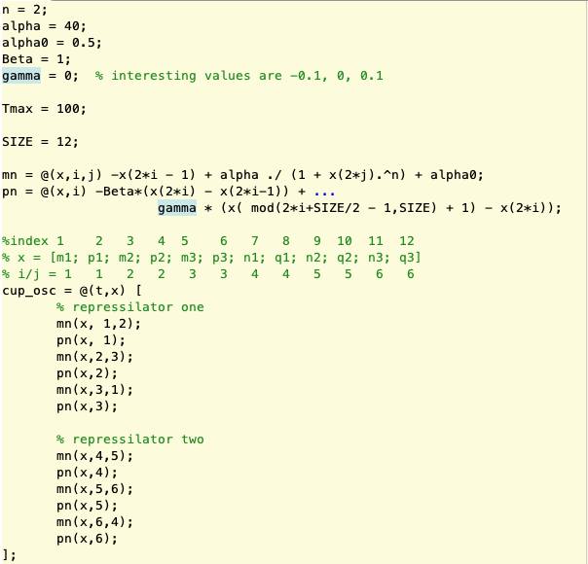

Next, we randomly assign an initial condition and numerically integrate our system.



Next, we prepare to plot the system in order to get a visual of the oscillatory behavior. For clarity, we plot the two oscillators separately, otherwise there would be too many species in a single plot.

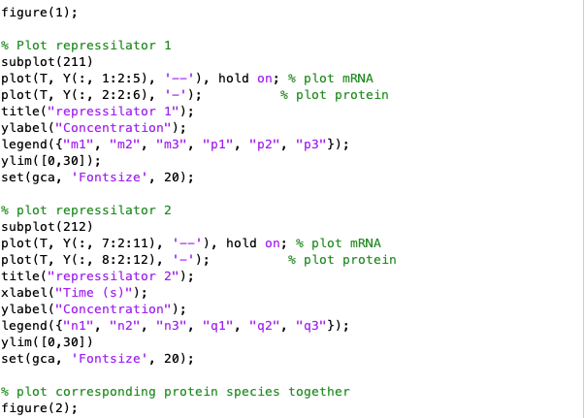

As we can see, both systems start at different initial conditions, but both inevitably reach a stable oscillation of approximately the same magnitude.

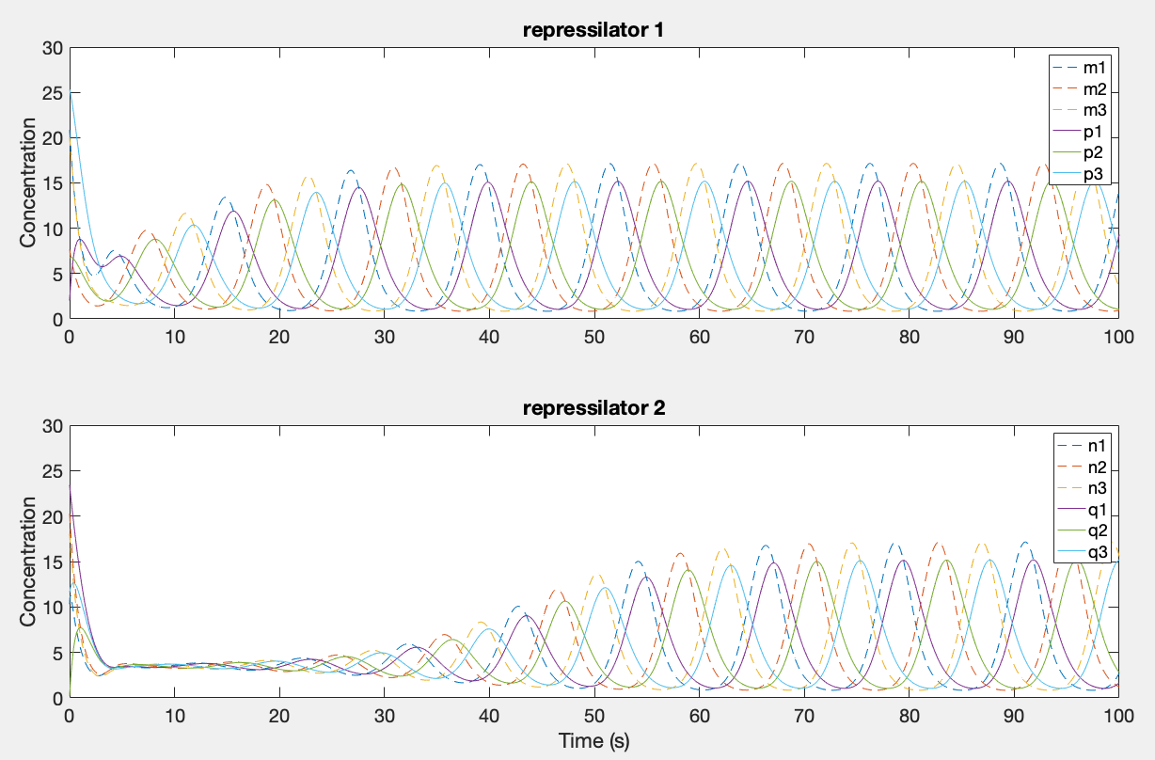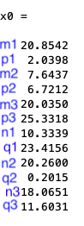

It is difficult to tell if these oscillations are in phase, so we plot corresponding parts separately. Additionally, we will plot the difference in concentration between these two parts as a function of time. Below, we can see that both corresponding species consistently reach an oscillation of approximately the same magnitude, however they are out of phase (unless they start at the same initial conditions). This makes sense as currently the system is uncoupled.

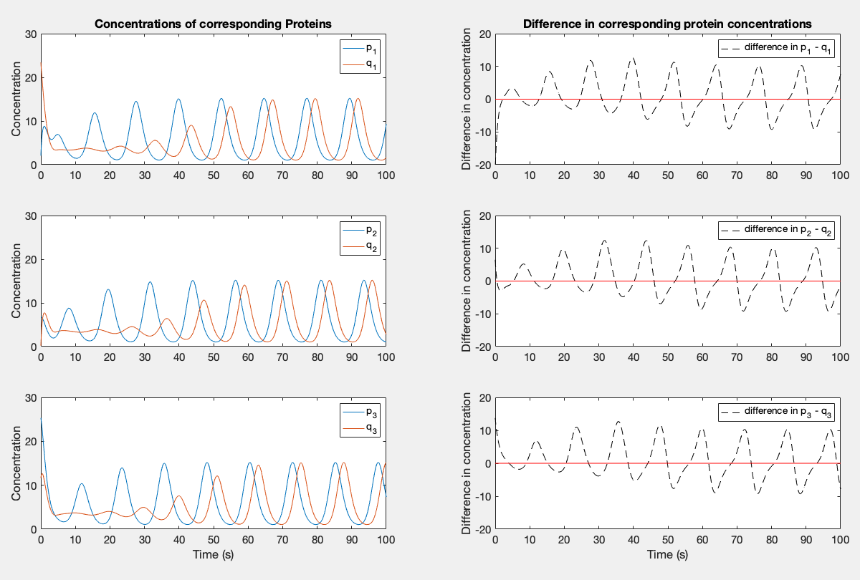

Now that we can see our system is properly set up, we will introduce coupling by selecting a nonzero gamma value. From trial and error, we have found that gamma values of 0.1 and -0.1 produce interesting results. Here, we observe that although the two systems start at significantly different initial conditions, their oscillations quickly converge/synchronize. This is because the interaction term pushes each term in the opposite direction of the difference. For example, if p1 > q1, p1 will have a negative interaction term in its time derivative, pushing its concentration lower while q1 will have a positive interaction term, pushing its concentration higher. Thus, the interaction term works to nullify the difference when gamma > 0. We can see this phenomenon in the plots below, as the difference quickly converges to zero. Below is gamma = 0.1.

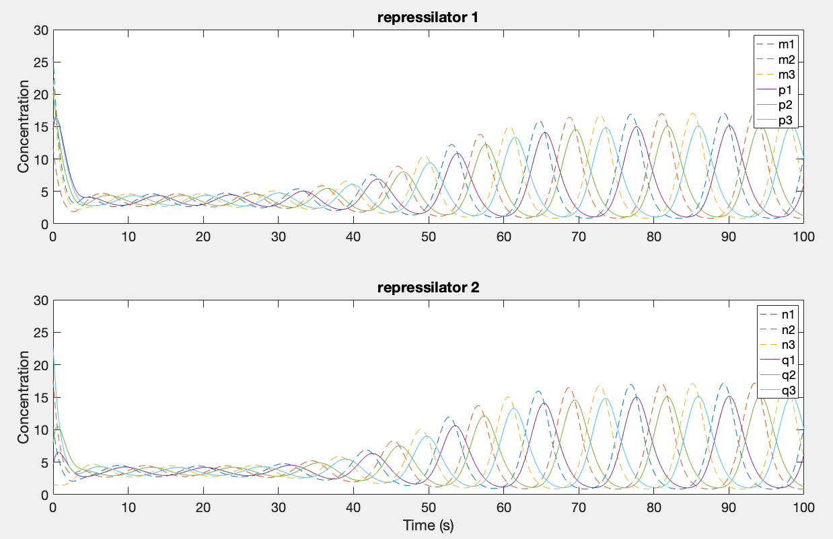 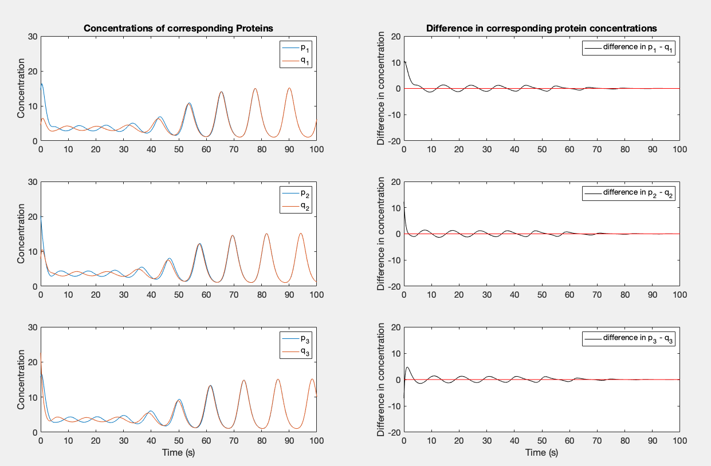

When gamma < 0, we have a different story. Now, the interaction term pushes each species in the direction of the difference, amplifying it. For example, if p1 > q1 then the interaction term in the time derivative of p1 will be positive due to the negative gamma, pushing p1 further above q1. Furthermore, the interaction term in q1 will be negative pushing q1 even lower. Thus, the interaction term serves to expand the difference. As a result of this, regardless of the initial conditions the two oscillators reach a point where they are completely out of phase (naturally maximizing the difference between corresponding species) and thus in this case the two oscillators do not synchronize. Below we see an example with gamma = -0.1.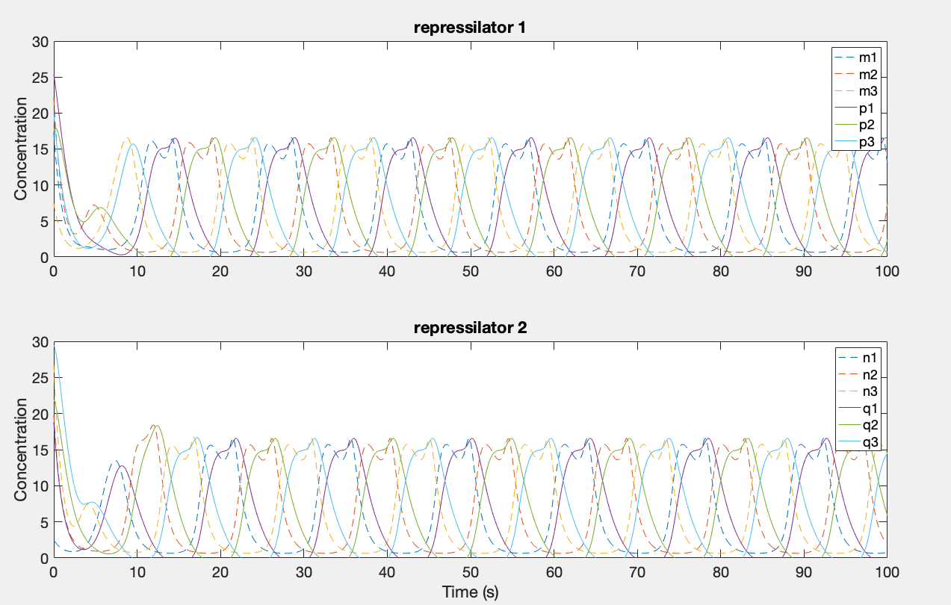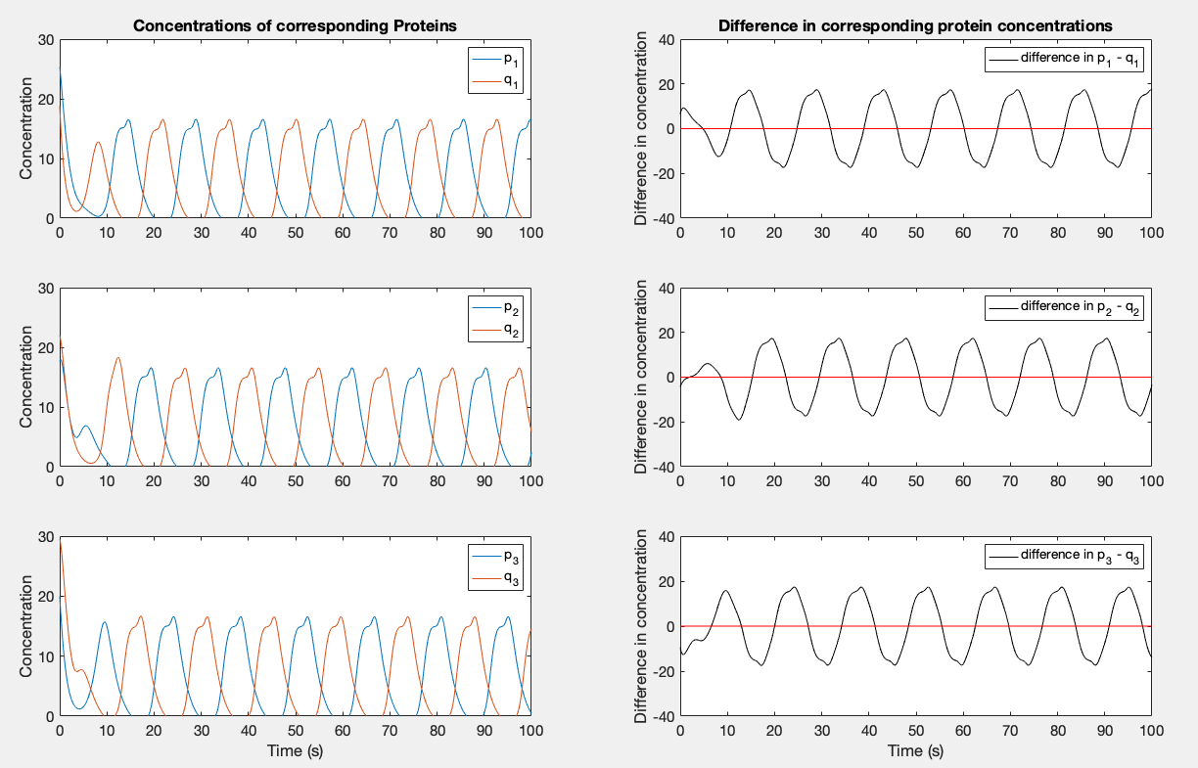

As we can see from the above two examples, gamma acts to re-align the two systems relative to each other. Whether it is positive or negative affects whether it forces them in phase or completely out of phase.

**Problem 2: Systems biology and network motifs**

In Figure 7 of the Nature Review Genetics paper by Alon (2007), the paper presents the following two systems. 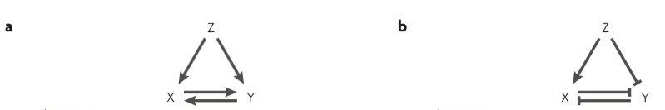

In figure 7a), we can see that X and Y exhibit a positive feedback loop. Once they are activated, they will continue to support each other’s activity. Z can act as an initial input to jumpstart the system. X will continue to be activated as long as either Y or Z are above some activation threshold, and Y will continue to be activated as long as either X or Z are above some activation threshold. To encode this information into a differential system of equations, we simply need to encode some of this boolean logic. We can encode this boolean OR logic using a simple max(A, B) statement, with ON = 1 and OFF = 0. Thus, if Z is ON and X is OFF, Y is max(Z,X) = max(1,0) = 1 = ON. These thresholds are somewhat arbitrary, so we simply pick reasonable results.

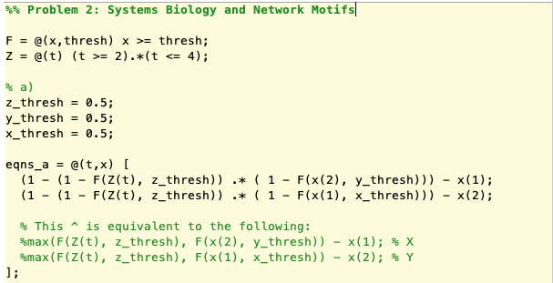

Next, we simply numerically integrate the system under our initial conditions and plot the results.



We can see this Boolean logic produces the correct steady-state value and overall shape of the graph. Furthermore, notice this OR conditin allows X and Y to remain at high activity after Z is shut off as the two simply activate each other.



For figure 7b), the Boolean logic is a bit different. In this case, X is activated by Z but also repressed by Y. Based on the graphs above, it seems activation by Z is more important than repression by Y, as even when Y is high X is activated in the prescence of Z. So for X to be ON, Z must be above some threshold, or Y must be below some threshold. On the other hand, as Y is repressed by both X and Z, for Y to be activated both X and Z must be below some threshold. Thus, Y acts as an AND gate, with the condition being both X and Z are below threshold. An AND gate acts as a min(A,B), but again this can be encoded using algebra. Again, the thresholds are chosen somewhat arbirtrarily, and we numerically integrate our system with the given initial conditions.

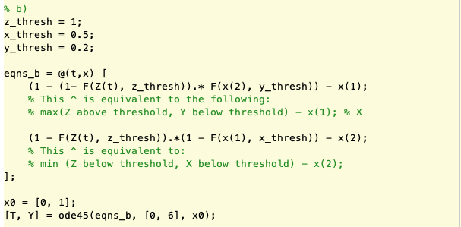

We can see this logic produces accurate steady-state values and the general shape of the graphs. Furthermore, after Z is shut-off both X and Y still exhibit the proper behavior, the idea of memory that the paper mentions.

